**Momentum Layout:**

If you change a ‘Process’

this will turn green

this will turn purple

click them in that order to Save

and be able to load a new ‘Work unit’

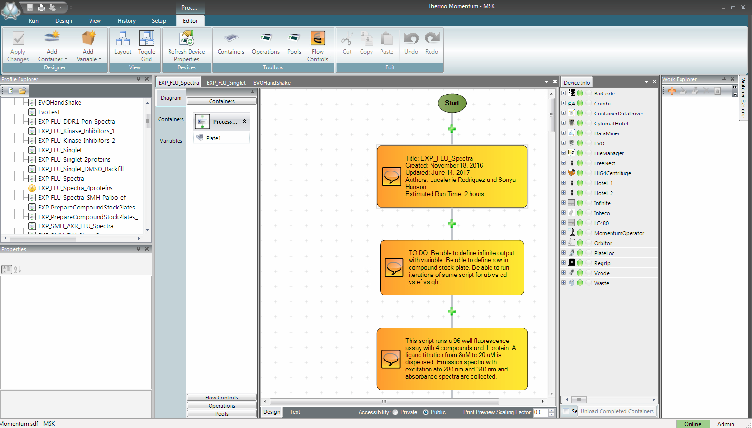

Take devices offline

to ‘Refresh Properties’

This is where you

actually write things